# Project Quality Management Specification Overview

**Revision Sheet**

|  |  |  |
| --- | --- | --- |
| **Release No.** | **Date** | **Revision Description** |
| Rev. 1 | 7/29/24 | Program Specifications |
|  |  |  |
|  |  |  |
|  |  |  |
|  |  |  |
|  |  |  |
|  |  |  |

Table of Contents

Project Quality Management Specification Overview 1

Overview 6

Functionality 6

Security 7

Overview 7

Login 8

Logged In/Main 9

Forget Password 10

Change Password 11

Administration 12

System Administration 13

Employee Maintenance 14

User Setup 15

Employee Role Setup 16

Organization Setup 17

Code Setup 18

Employee Setup 19

Employee Update 20

Project Administration 21

Create Project 22

Close Project 23

Assign Persons 24

Assign Tasks 25

Workflows 26

DMAIC 27

Overview 28

Define 29

Project Charter 30

Initial Project Charter 31

Approve Project Charter 32

View Project Charter Workflow 33

Project Plan 34

Initial Project Plan 35

Initial Project Plan General Tab 36

Initial Project Plan- Project Team Tab 37

Initial Project Plan- Scope 38

Initial Project Plan- Budget 39

Initial Project Plan- Risk 40

Initial Project Plan- Communication Plan 41

Initial Project Plan- Timeline 42

Approve Project Plan 43

View Project Plan Workflow 44

Business Requirements 45

SIPOC 46

Stakeholder Analysis 47

VOC 48

Measure 49

Project Charter 50

Updated Project Charter 51

Approve Updated Project Charter 52

View Updated Project Charter Workflow 53

Project Plan 54

Updated Project Plan 55

Updated Project Plan General Tab 56

Updated Project Plan- Project Team Tab 57

Updated Project Plan- Scope 58

Updated Project Plan- Budget 59

Updated Project Plan- Risk 60

Updated Project Plan- Communication Plan 61

Updated Project Plan – Timeline 62

Approve Updated Project Plan 63

View Updated Project Plan Workflow 64

Data Collection Plan 65

Data Collected 66

Other Documents Collected 67

Analyze 68

Pareto Chart 69

Gap Analysis 70

STEP Analysis 71

Correlation 72

Other Data Analysis 73

Detailed Process Map 74

RACI 75

Improve 76

Project Charter 77

Updated Project Charter 78

Approve Updated Project Charter 79

View Updated Project Charter Workflow 80

Project Plan 81

Updated Project Plan 82

Updated Project Plan General Tab 83

Updated Project Plan- Project Team Tab 84

Updated Project Plan- Scope 85

Updated Project Plan- Budget 86

Updated Project Plan- Risk 87

Updated Project Plan- Communication Plan 88

Updated Project Plan – Timeline 89

Brainstorm 90

Cost Benefit 91

FMEA 92

Force Field 93

How Now Wow 94

Pugh 95

Cost Benefit 96

Transition Plan/Adkar 96

Procedure Manual 97

Implementation Plan 98

Control 99

Control Plan 100

Control Chart Upload 101

Measurement Plan Analysis Uploaded 102

Appendix – Database Diagrams 103

Security 103

User 104

Workflow 105

Reporting 106

Quality 107

Projects 108

Phase Artifact 109

Phase 110

Employee 111

DMAIC 112

Define 112

Business Requirements 113

Project Charter 114

Project Plan 115

SIPOC 116

VOC 117

Measure 118

Data Collection 119

Other Documents 120

Analyze 121

Affinity 122

Fishbone 123

Five Whys 124

GAP Analysis 125

Step Analysis 126

Pareto Analysis 127

Mindmap 128

RACI 129

Improve 130

Cost Benefit 131

Force Field 132

Procedure Manual 133

Pugh 134

Control 135

Lesson Learned 136

Implementation Plan 137

# Overview

The Data Quality Project Administration application

# Functionality

There are six major areas of concern in the first release:

|  |  |  |
| --- | --- | --- |
| **Area** | **Description** | **Comments** |
| Security | The User must be able to: Log onto the application |  |
| DMAIC |  |  |
| Administration |  |  |
| Projects |  |  |
| Documentation |  |  |
| Help |  |  |

## Security

### Overview

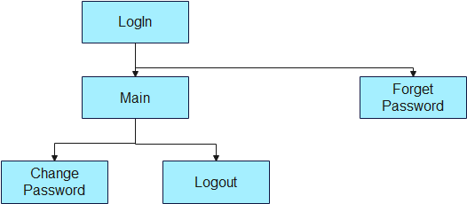

The security area consists of the following functions:

Login -

|  |  |  |  |
| --- | --- | --- | --- |
| **Action** | **Role** | **Description** | **Comments** |
|  |  |  |  |
| Login | All | The user logs in. Once the user logs in, he sees and can access the options that he has access to. |  |
| Forget Password | All | If the user forgets their password they can enter their user id and the email address. The system then sends a link to the user to reset their password. |  |
| Change Password | All | The user can change their password by entering the old password, the new password and verifying the new password. |  |
| Logout | All | The user can |  |
| Main | All |  |  |

### Login

The user enters his user id and password. The form checks if:

1. The user no is entered
2. The password is Entered
3. The password length is greater than 8 characters
4. The password must contain a lower case letter

The system then:

1. Checks that the user with that password exists.
2. Records that the user is logged by adding the loggedIn field to the session.
3. Adds the user’s role to the session

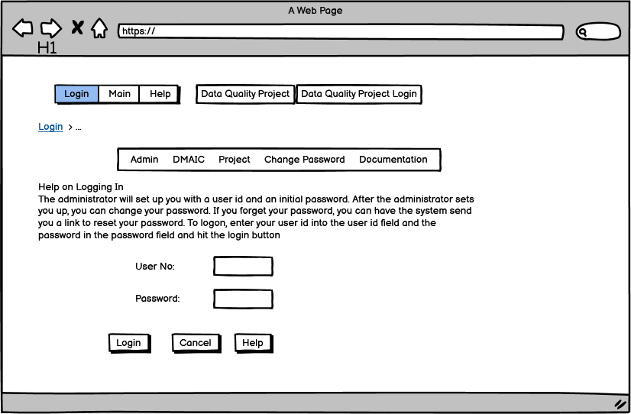

### Logged In/Main

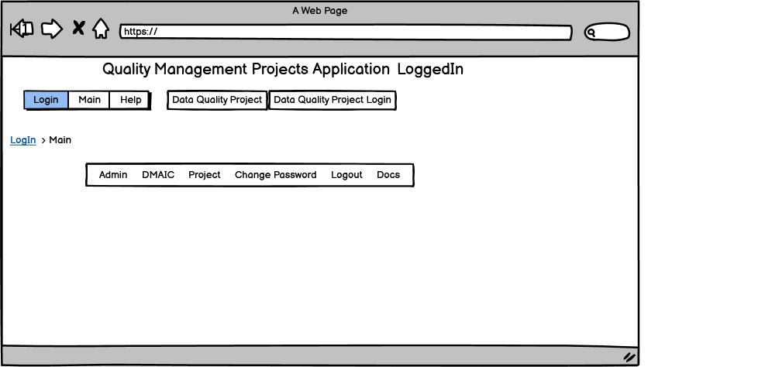

Once the user is logged on, the system checks the roles that the user has and generates the main menu.

There are various roles that a user can have:

* System Administrator
* Project Administrator
* Sponsor
* Quality Analyst
* Stakeholder

Every role has access to the docs,login, logout, forget password and change password functions.

The System Administrator has access to:

* the Admin menu and
* The System Admin menu under it

The Project Administrator has access to:

* the Admin menu and
* The Project Admin menu under it

The Sponsor has access to:

* The approval functions
* The view workflow functions
* View/Download functions

The quality analyst can upload documents and fill out forms.

The stakeholder gets notified of certain events (approval of Project Charter and Plan, for instance).

### Forget Password

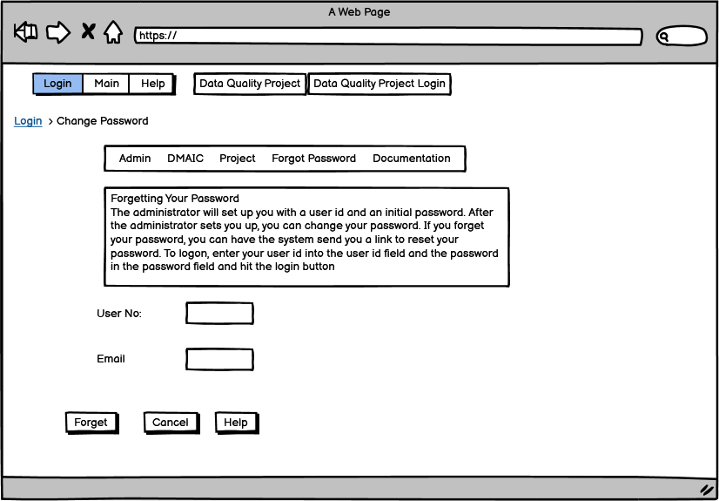

The user

### Change Password

## Administration

### System Administration

The system administration function consists of the following functions:

* Employee Maintenance
* User Setup
* Organization Setup
* Code Setup

#### Employee Maintenance

#### User Setup

#### Employee Role Setup

#### Organization Setup

#### Code Setup

#### Employee Setup

#### Employee Update

### Project Administration

#### Create Project

#### Close Project

#### Assign Persons

#### Assign Tasks

#### Workflows

## DMAIC

### Overview

### Define

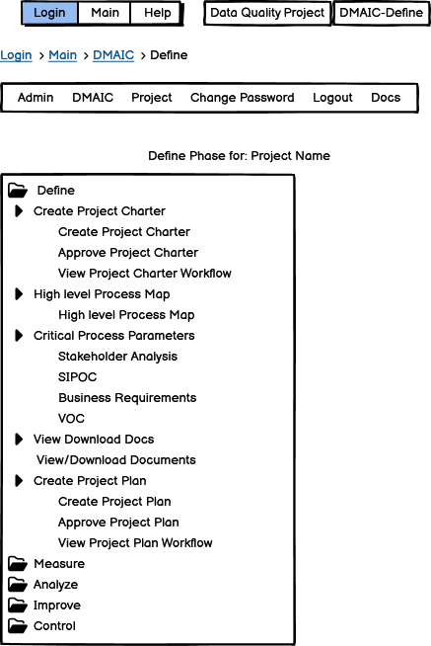

The define menu allows access to the following options:

* Creating, approving, and viewing approval workflows for Project Charters
* Creating, approving, and viewing approval workflows for Project Plans
* Create Process/Value Stream Map
* Create a Stakeholder Analysis, SIPOC (Supplier, Input, Processing, Output, Customer), Business Requirements and Voice of the Customer
* View or download all of the documents (for those that are entered online it will generate either a word or excel document as appropriate)

#### Project Charter

Maintaining the Project Charter consists of three activities:

* Creating the Project Charter
* Approving the Project Charter
* View the Project Charter Workflow

##### Initial Project Charter

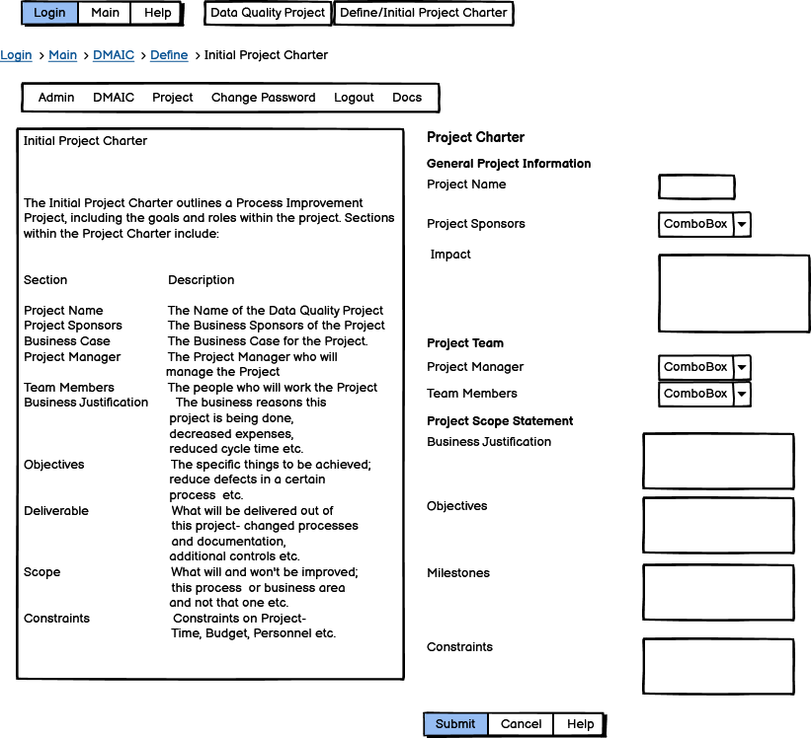

The Initial Project Charter consists of the following fields:

|  |  |  |
| --- | --- | --- |
| Section | Field | description |
| General | Name | The name of the Project |
| General | Sponsors | Can pick more than one from the dropdown |
| General | Impact | What is the expected impact of the Project? How much difference will this make on the business? |
| Team | Manager | Can pick one |
| Team | Members | Can pick more than one |
| Scope | Justification | Why are we doing this? Reduced costs, increased revenue, decreased risk/cycle time etc. |
| Scope | Objective | Reduced costs by X etc. |
| Scope | Milestone | Set of Milestones with dates |
| Scope | Constraints | Must be done by date, must cost no more than etc. |

##### Approve Project Charter

The Project Administrator selects a project he wishes to approve the charter for and then clicks on submit.

##### View Project Charter Workflow

#### Project Plan

Creating the Project Plan consists of three activities:

* Creating the Project Plan
* Approving the Project Plan
* View the Project Plan Workflow

##### Initial Project Plan

The Project Plan consists of the following sections:

|  |  |
| --- | --- |
| Section | description |
| General Project Information | The name of the Project, Sponsors and Impact |
| Team Members | Manager and Team Members |
| Scope | Justification, Objectives, Deliverables, Scope, Milestones and Constraints |
| Budget | Time Period, Actual, Budget and Forecast Amounts |
| Risk | Name,Impact, Likelihood, Mitigation |
| Communication | Communication, Frequency, Objective, Owner, Audience |
| Timeline | Task Name, Milestone, Planned Start Date, Planned End Date, Assigned to |

###### Initial Project Plan General Tab

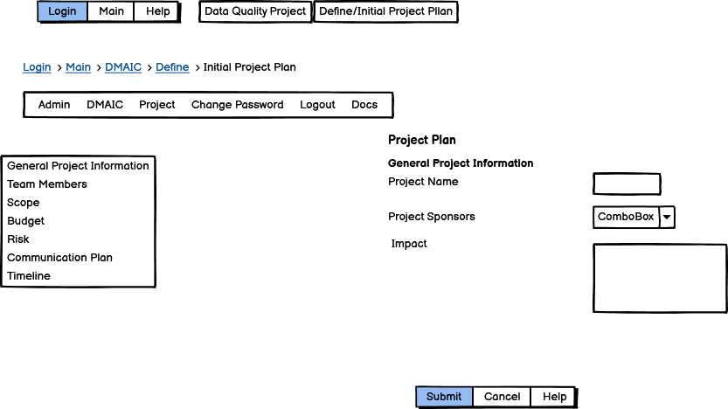

###### Initial Project Plan- Project Team Tab

###### Initial Project Plan- Scope

###### Initial Project Plan- Budget

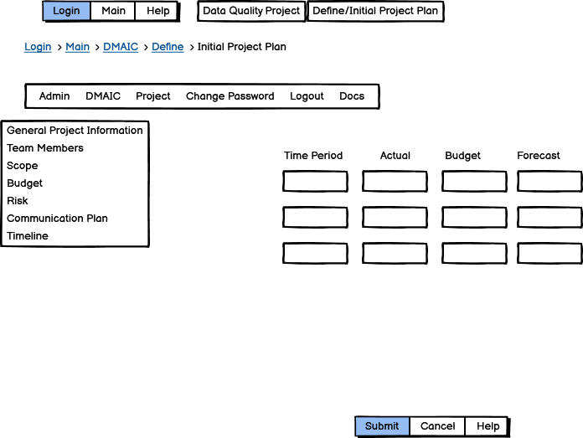

###### Initial Project Plan- Risk

###### Initial Project Plan- Communication Plan

###### Initial Project Plan- Timeline

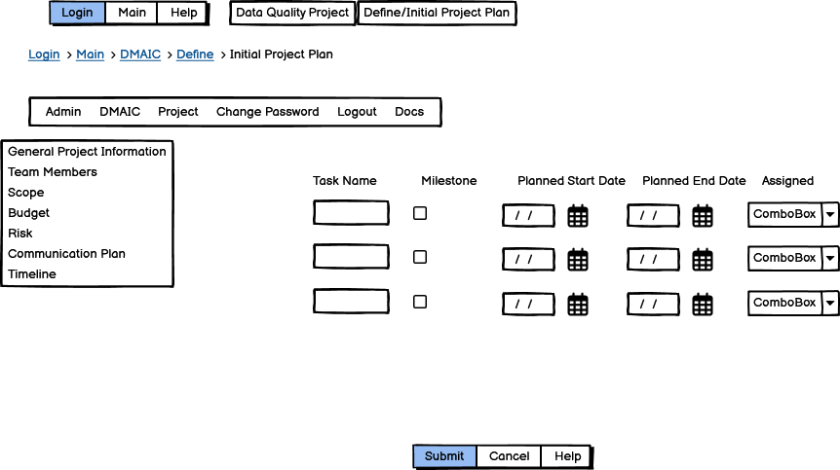

##### Approve Project Plan

##### View Project Plan Workflow

#### Business Requirements

#### 

#### SIPOC

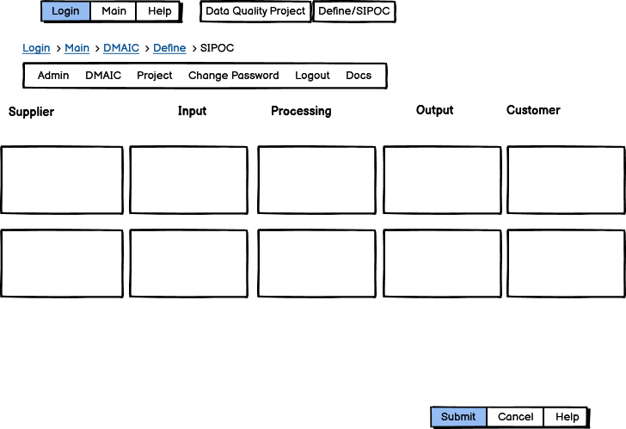

#### Stakeholder Analysis

#### VOC

### Measure

#### Project Charter

Maintaining the Project Charter consists of three activities:

* Updating the Project Charter
* Approving the Updated Project Charter
* View the Project Charter Workflow

##### Updated Project Charter

1. 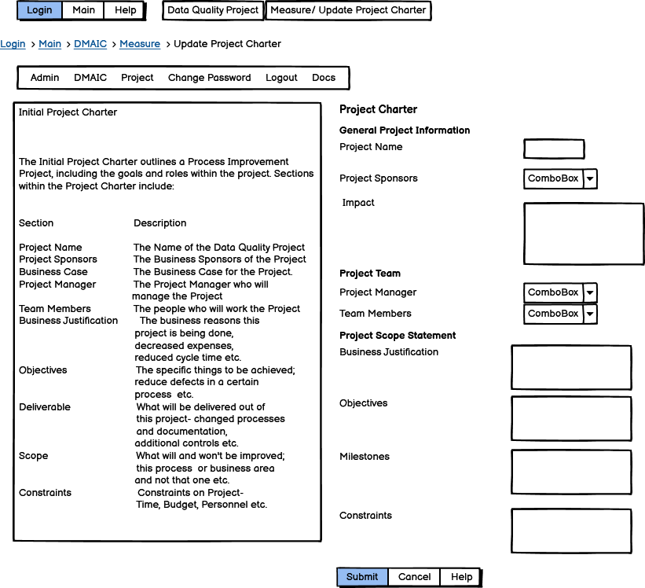

The Project Charter

##### Approve Updated Project Charter

##### View Updated Project Charter Workflow

#### Project Plan

Maintaining the Project Plan consists of three activities:

* Updating the Project Plan
* Approving the Project Plan
* View the Project Plan Workflow

##### Updated Project Plan

The Project Plan consists of the following sections:

|  |  |
| --- | --- |
| Section | description |
| General Project Information | The name of the Project, Sponsors and Impact |
| Team Members | Manager and Team Members |
| Scope | Justification, Objectives, Deliverables, Scope, Milestones and Constraints |
| Budget | Time Period, Actual, Budget and Forecast Amounts |
| Risk | Name,Impact, Likelihood, Mitigation |
| Communication | Communication, Frequency, Objective, Owner, Audience |
| Timeline | Task Name, Milestone, Planned Start Date, Planned End Date, Assigned to |

###### Updated Project Plan General Tab

1. 

###### Updated Project Plan- Project Team Tab

###### Updated Project Plan- Scope

###### Updated Project Plan- Budget

###### Updated Project Plan- Risk

###### Updated Project Plan- Communication Plan

###### Updated Project Plan – Timeline

##### Approve Updated Project Plan

##### View Updated Project Plan Workflow

#### Data Collection Plan

#### Data Collected

#### Other Documents Collected

### Analyze

#### Pareto Chart

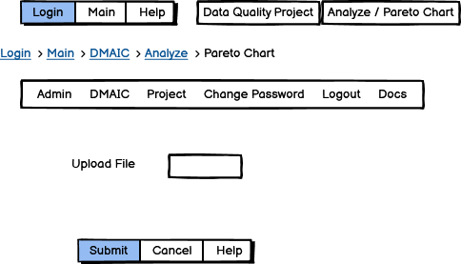

#### Gap Analysis

#### STEP Analysis

#### Correlation

#### Other Data Analysis

#### Detailed Process Map

#### RACI

### Improve

#### Project Charter

##### Updated Project Charter

1. 

The define menu allows access to the following options:

##### Approve Updated Project Charter

##### View Updated Project Charter Workflow

#### Project Plan

##### Updated Project Plan

###### Updated Project Plan General Tab

###### Updated Project Plan- Project Team Tab

###### Updated Project Plan- Scope

###### Updated Project Plan- Budget

###### Updated Project Plan- Risk

###### Updated Project Plan- Communication Plan

###### Updated Project Plan – Timeline

#### Brainstorm

#### Cost Benefit

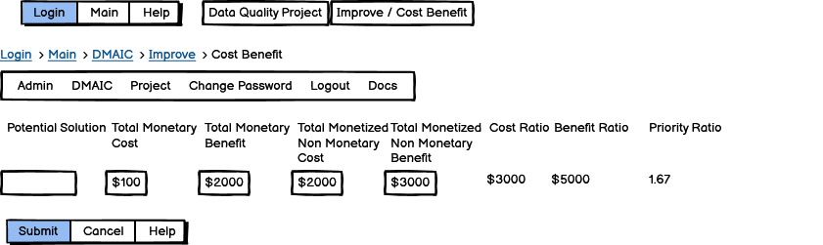

#### FMEA

#### Force Field

#### How Now Wow

#### Pugh

#### Cost Benefit

#### Transition Plan/Adkar

#### Procedure Manual

#### Implementation Plan

### Control

#### Control Plan

#### Control Chart Upload

#### Measurement Plan Analysis Uploaded

#### Process Capability Analysis Uploaded

#### Cost Benefit Analysis

#### Organizational Readiness

#### Training Plan

#### Transition Plan

# Appendix – Database Diagrams

## Security

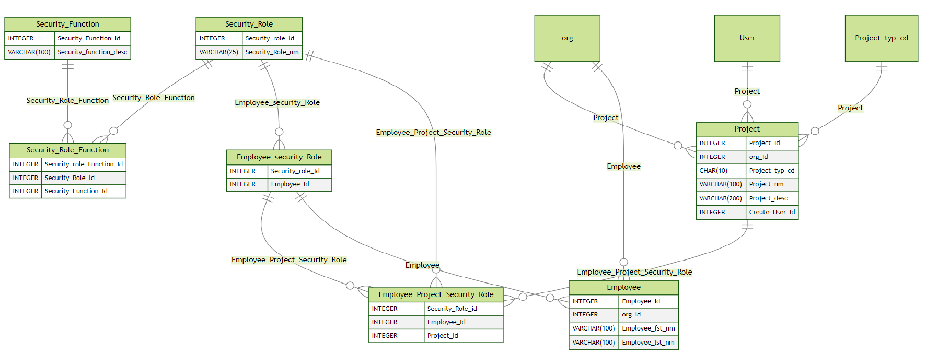

## User

## Workflow

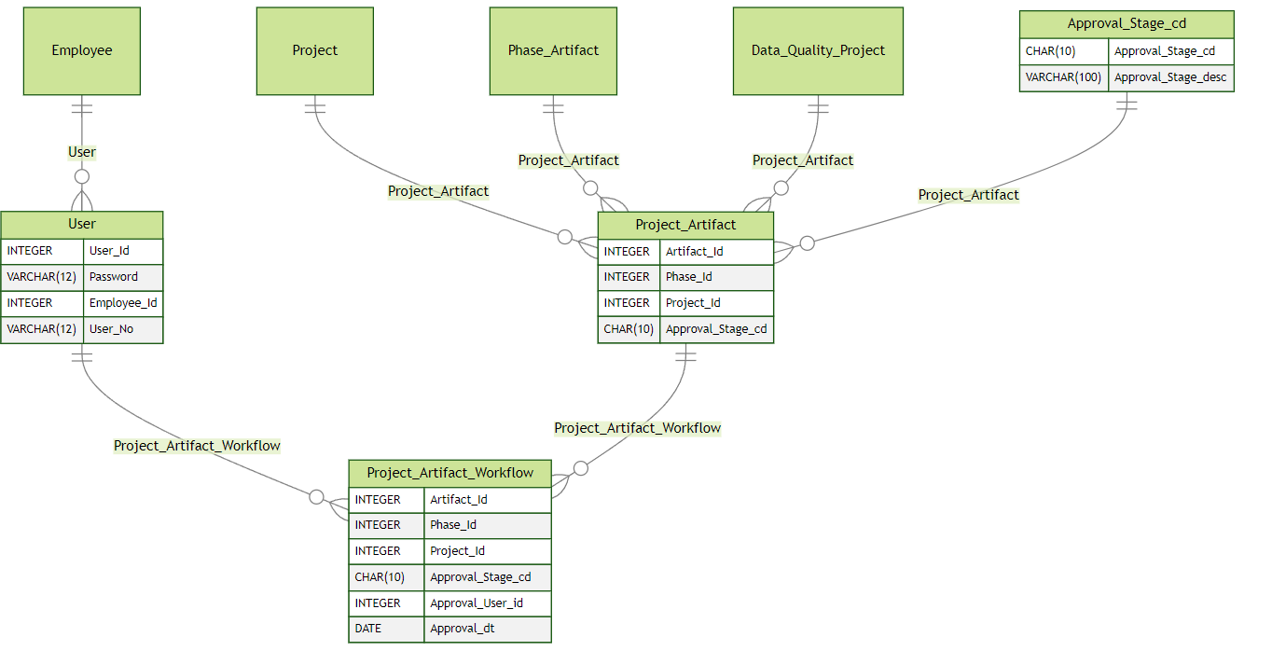

## Reporting

## Quality

## Projects

## Phase Artifact

## Phase

## Employee

## DMAIC

### Define

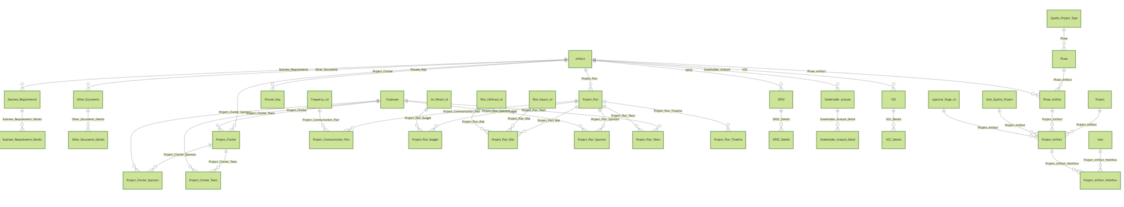

#### Business Requirements

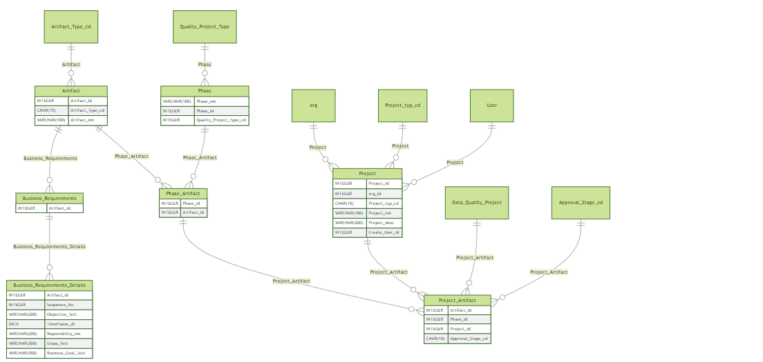

#### Project Charter

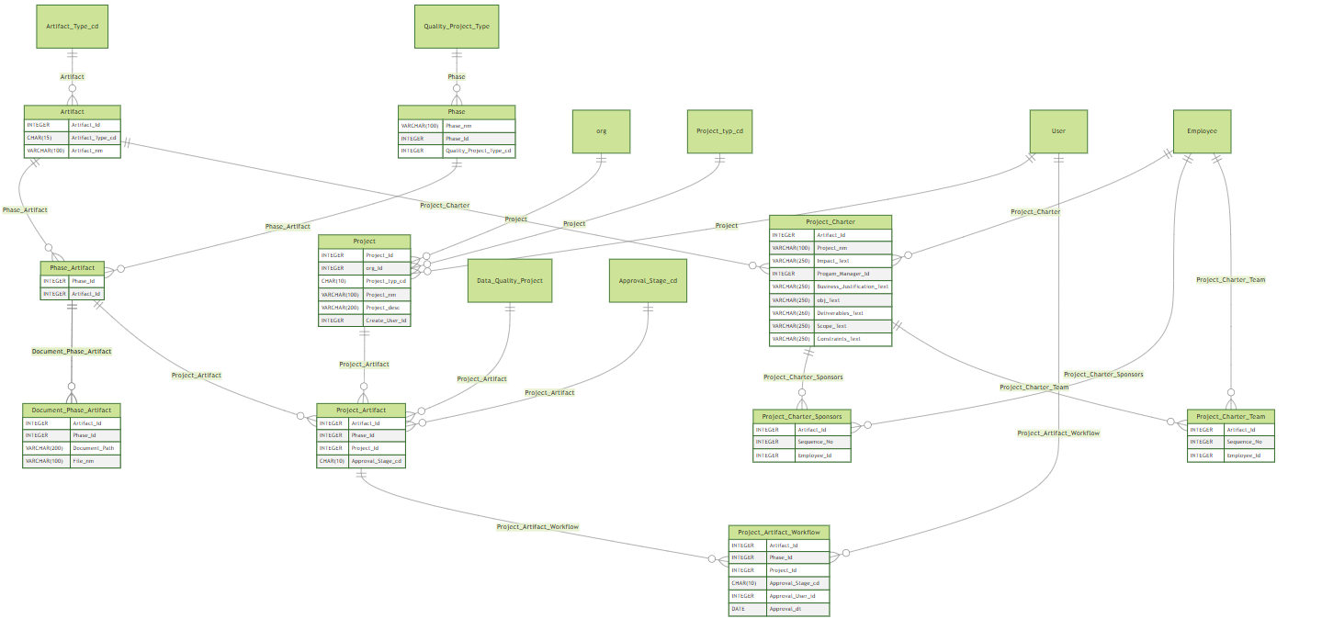

#### Project Plan

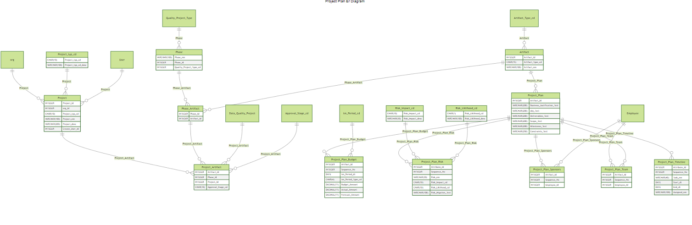

#### SIPOC

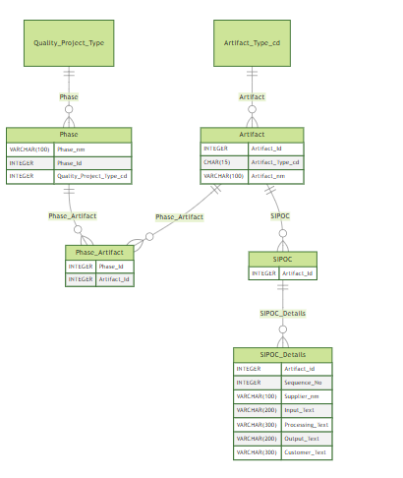

#### VOC

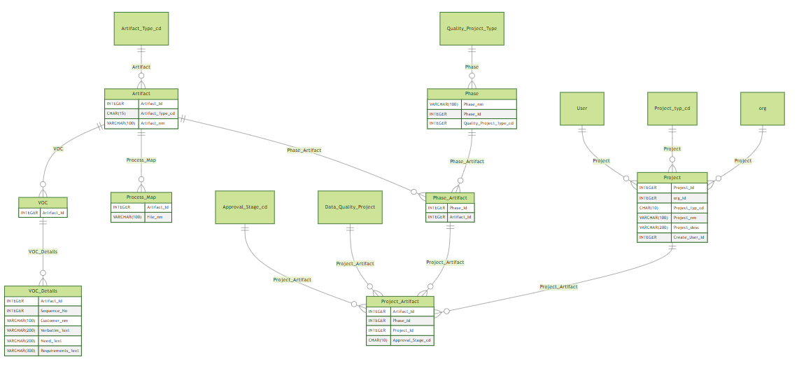

### Measure

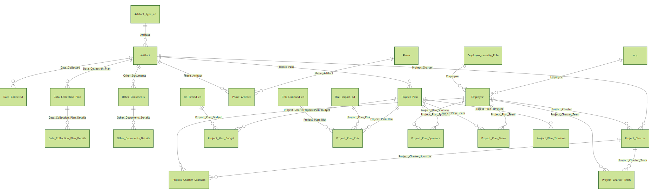

### Data Collection

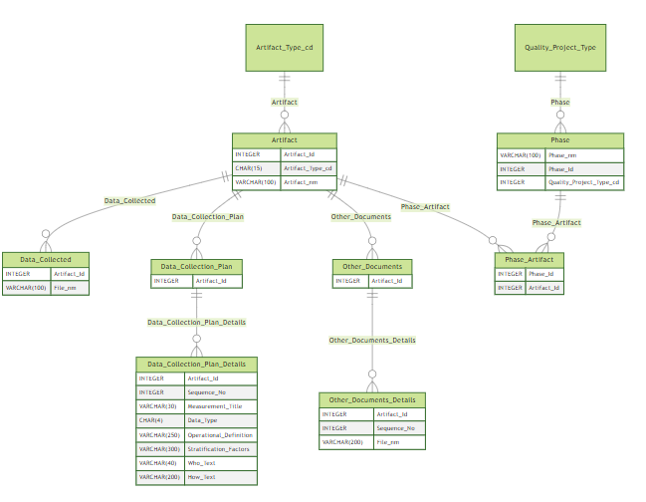

#### Other Documents

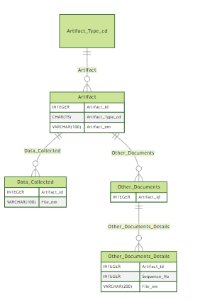

### Analyze

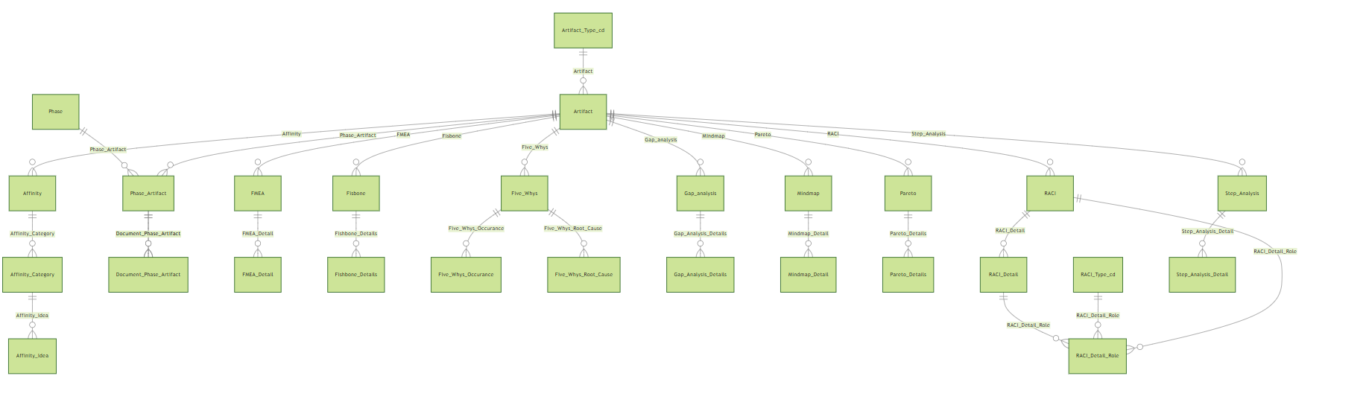

#### Affinity

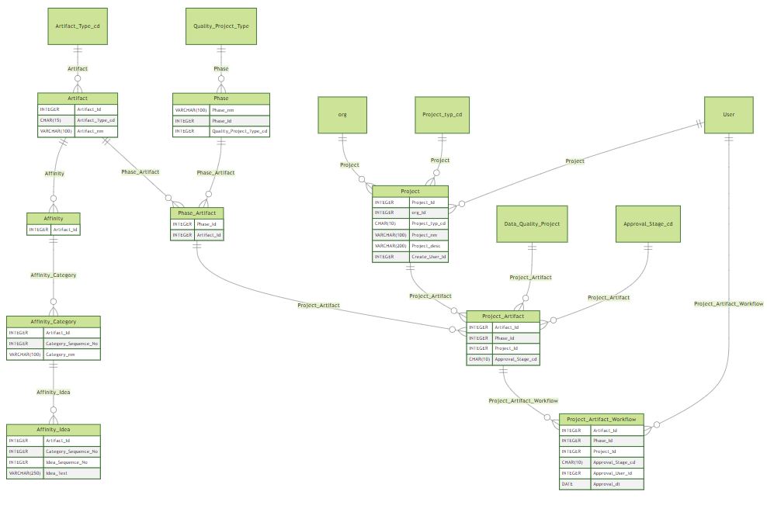

#### Fishbone

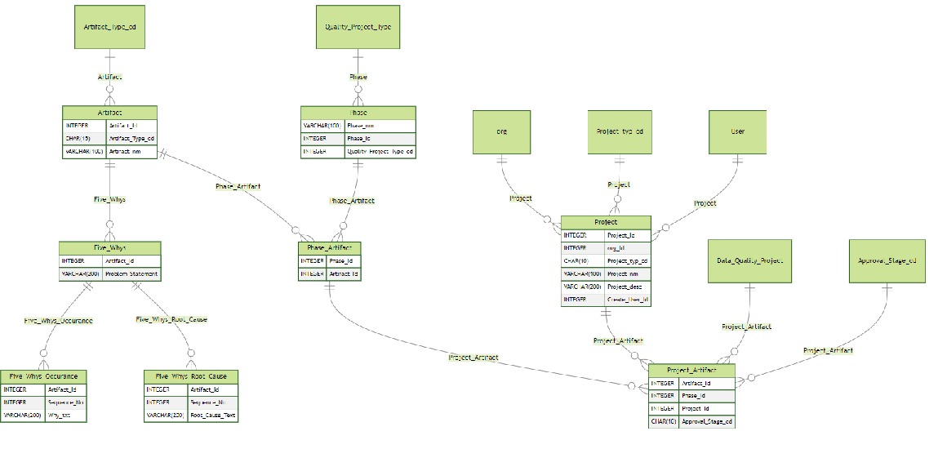

#### Five Whys

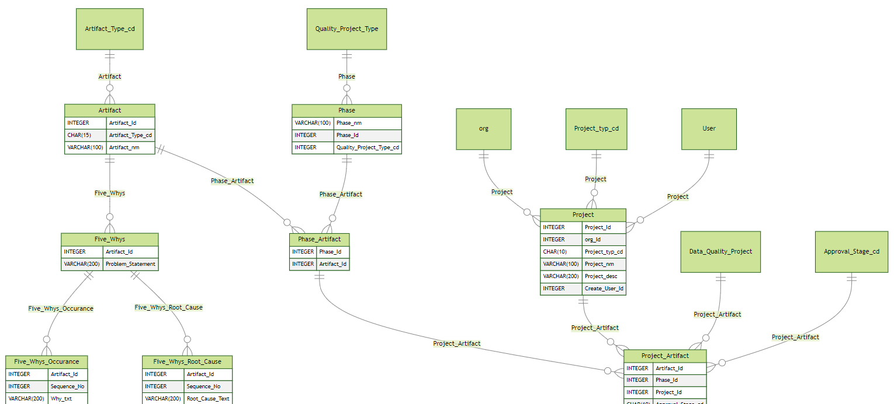

#### GAP Analysis

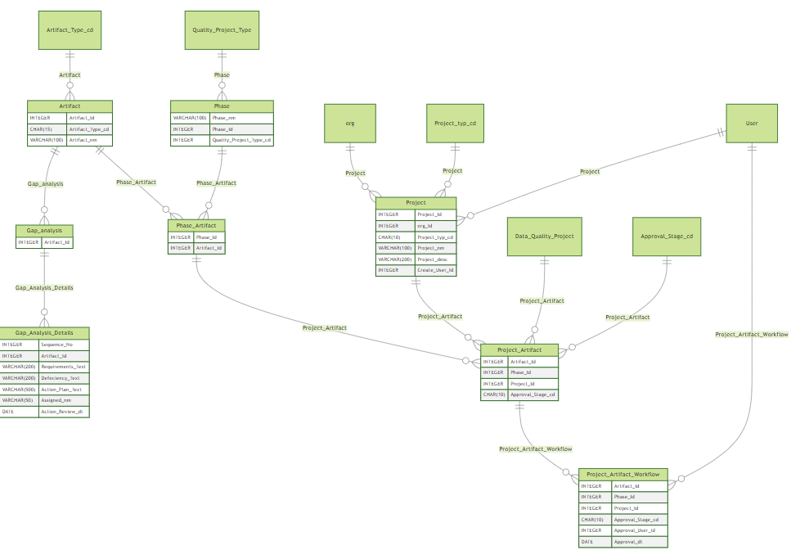

#### Step Analysis

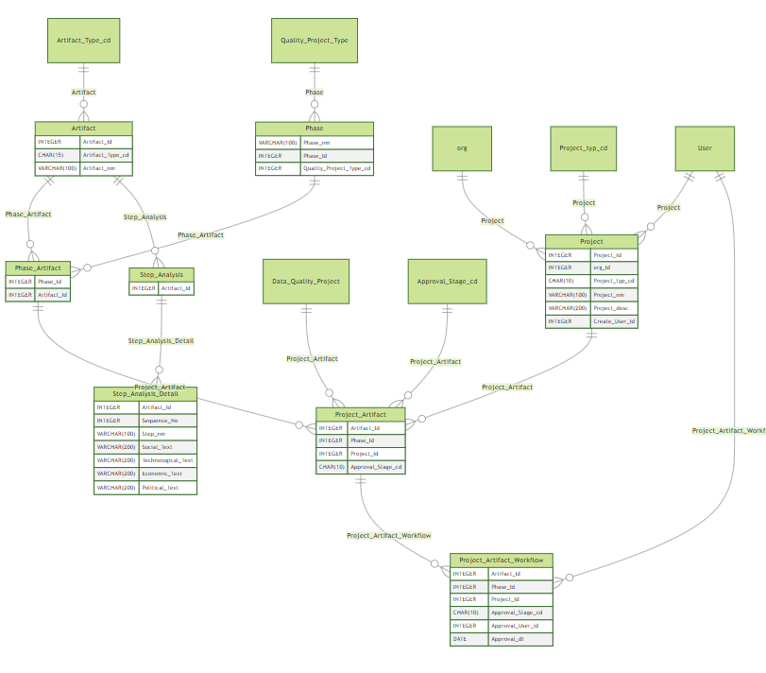

#### Pareto Analysis

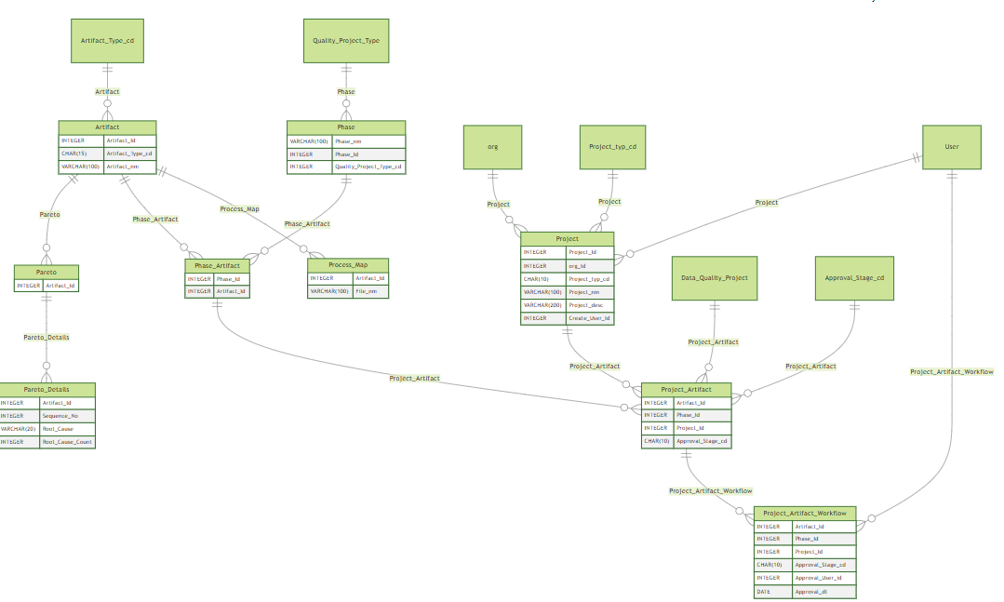

#### Mindmap

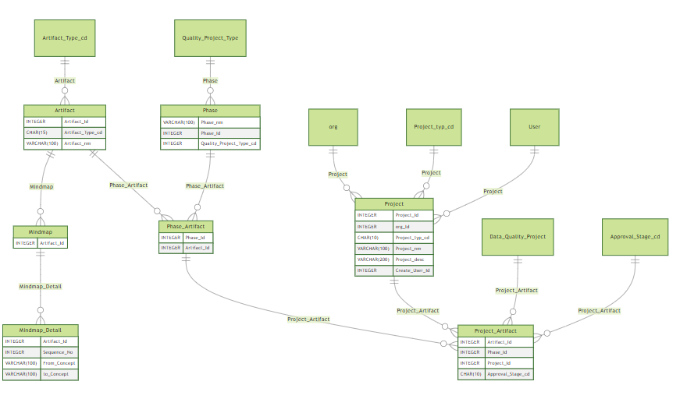

#### RACI

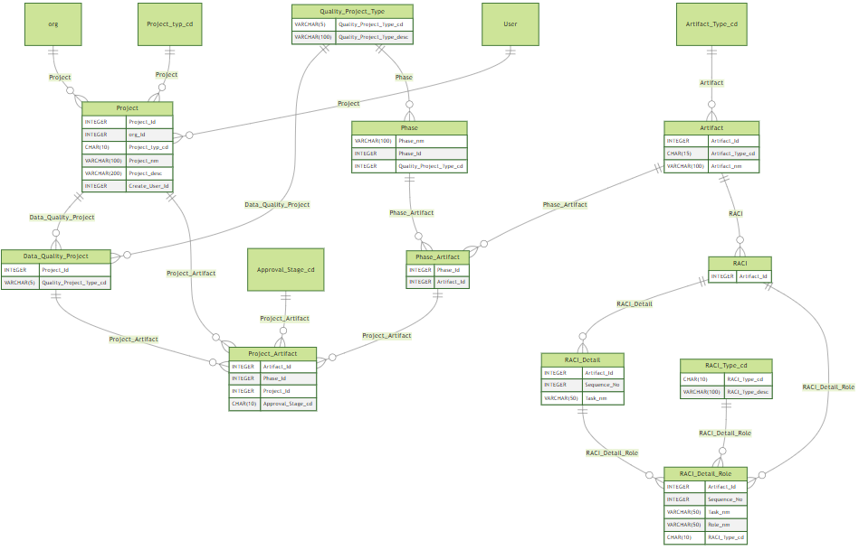

### Improve

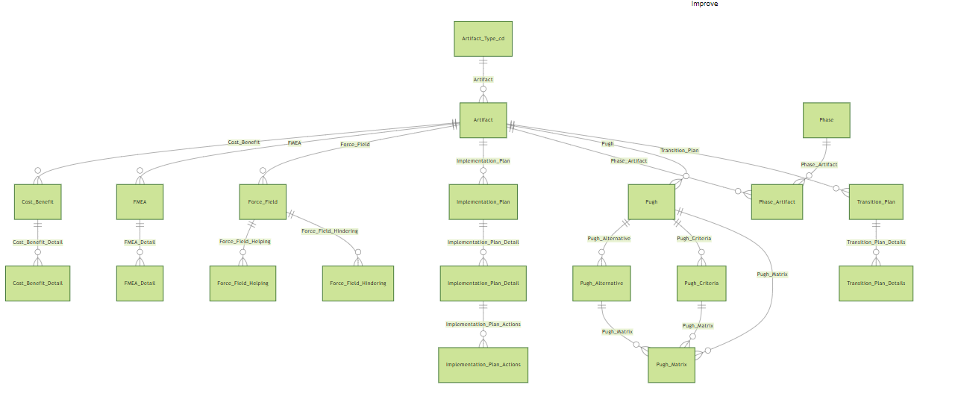

#### Cost Benefit

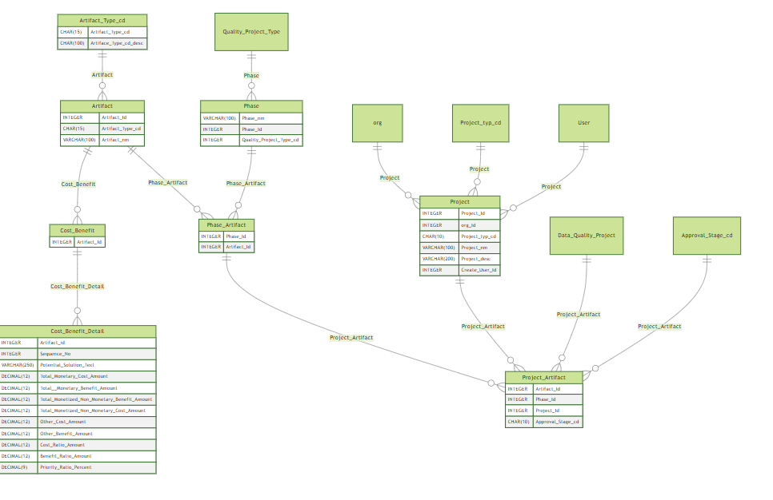

#### Force Field

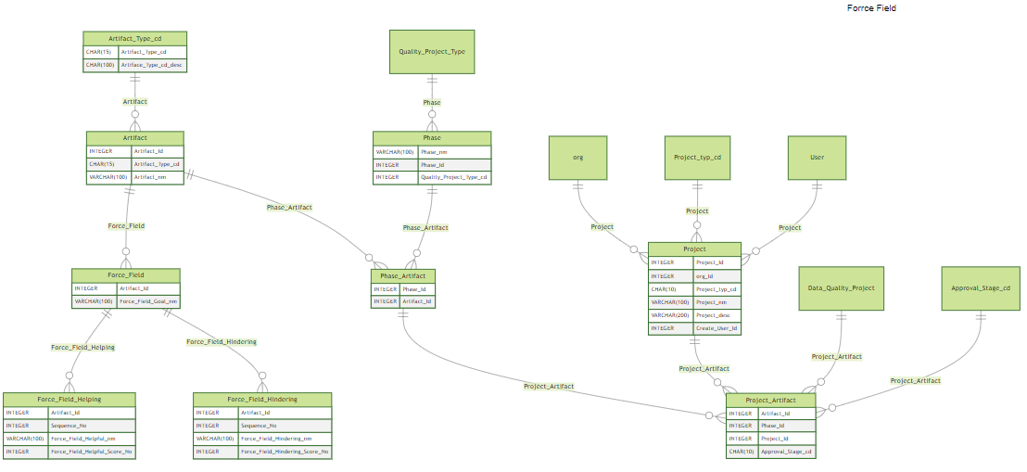

#### Procedure Manual

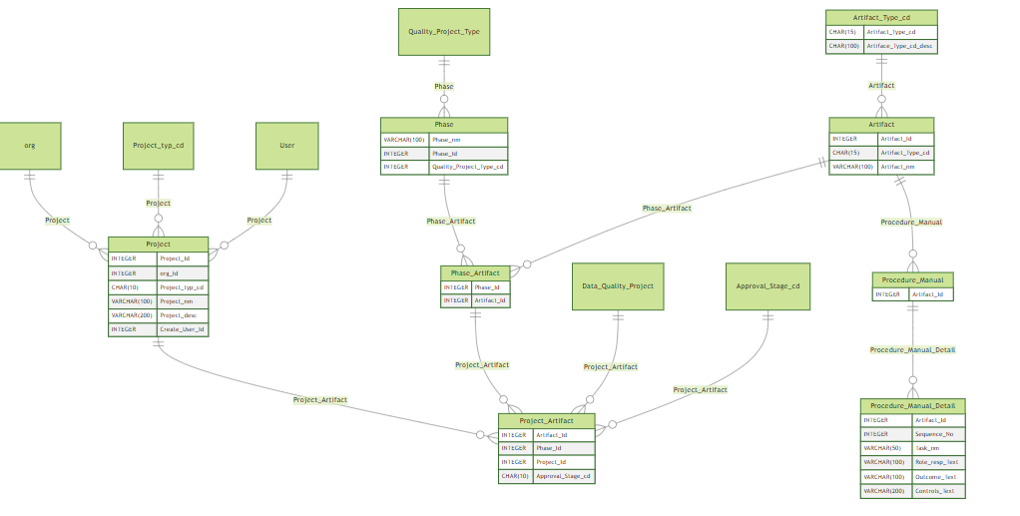

#### Pugh

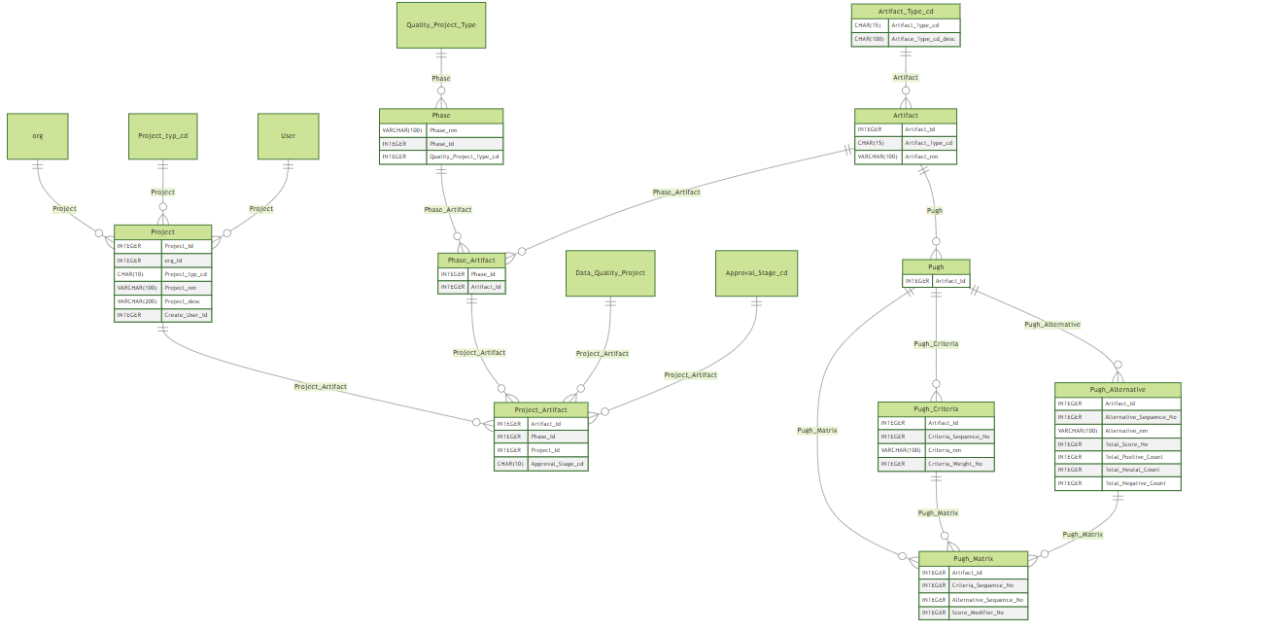

### Control

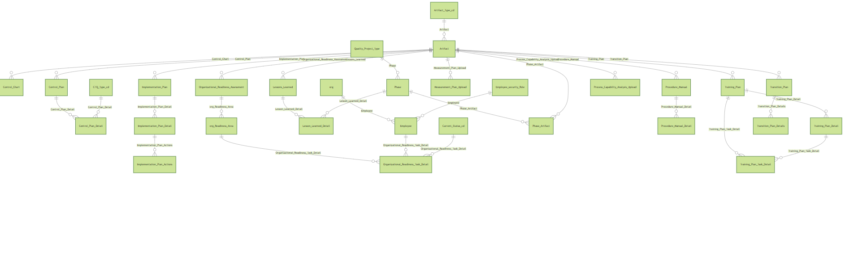

#### Lesson Learned

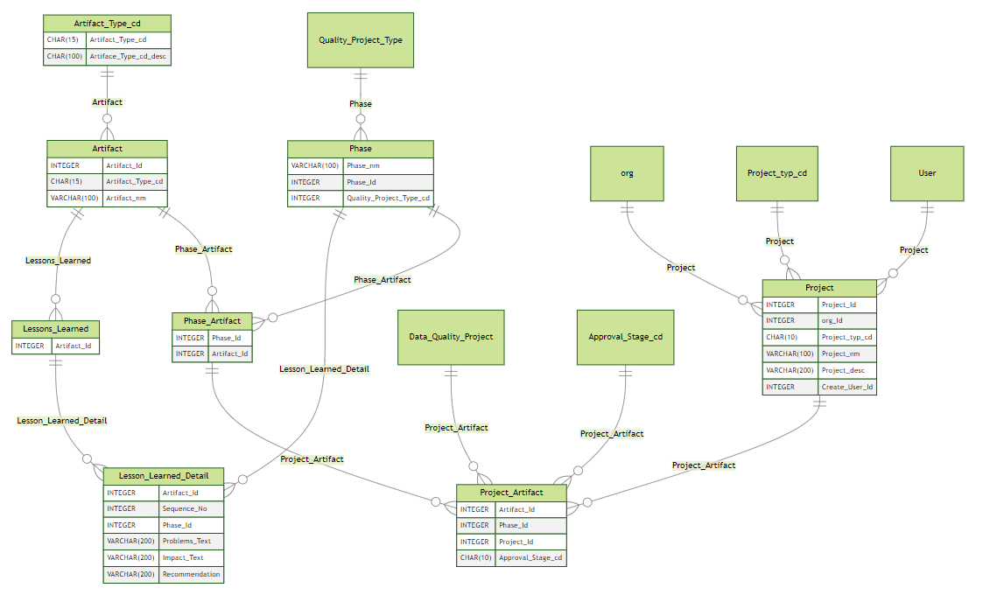

#### Implementation Plan

